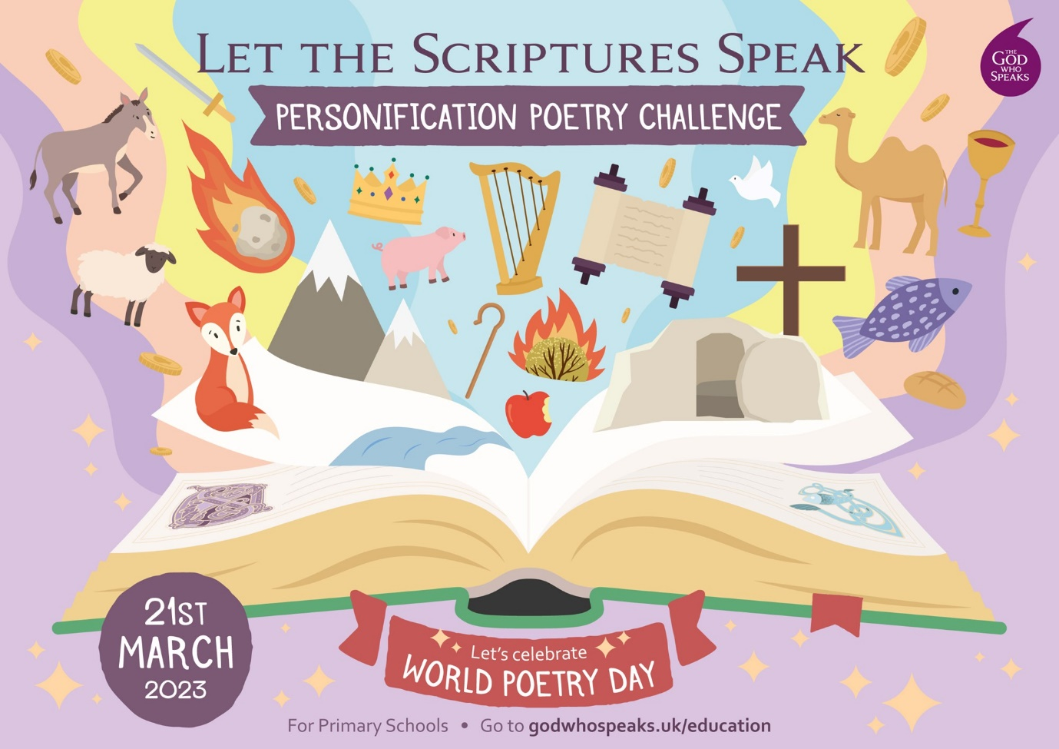

LET THE SCRIPTURES SPEAK
A poetry challenge for Key Stage 2.
Engage your pupils with the Bible and develop their creative and poetic skills.

KEY OUTCOMES:
Children learn how to write and illustrate poetry drawing on Bible stories.
Children develop a deeper and richer understanding of Scripture.

IMPACT: Pupils more confident and competent to write imaginatively from Scripture and enhance their biblical, literary and artistic skills and gifts.

ONLINE LAUNCH DATE: 21st March 2023 – World Poetry Day.

Bible Society, The God Who Speaks and Tony Bower welcome you to our Poetry Challenge!
‘Tony Bower is a master of both the spoken and written word. I put one of Tony’s personification poems to good use in a workshop with my final year trainee primary school teachers and it went down a storm!
Encore! Encore!’
Garrie-John Barnes,
Lecturer in Primary Education,
University of Huddersfield.

Let the Scriptures Speak: A poetry challenge for all our primary schools.

Personification Poetry for KS2
Personification is a powerful poetic device which is used in ‘Let the Scriptures Speak’ to inspire the use of creative imagination in writing poetry.
Used since ancient times, this device allows readers to understand philosophical concepts.
It draws us in, provides a hook and brings to life the words on the page.

‘Let the Scriptures Speak’ offers examples of Bible based personification poetry where Scripture itself speaks! Pupils are encouraged to explore the poems to inspire their own personification poems based on the same stories and on a selection of other Bible stories.

Introduction to this poetry challenge
This is a dynamic and creative way of writing.
This is a different way of illustrating and drawing poetry.
This is a fun way of engaging with the Bible.
This is a great way for students to reflect on what is happening in the Bible story.
This is a cross curriculum combination of RE, English, history, geography, art and drama.
This is an opportunity to have the work of the class showcased through the God who Speaks website and through Bible Society.

Step by step guide
- Introduce the class to the poetry challenge of retelling a Bible story through personification poetry.
- Use an example from the poems included and read it out loud.
- Ask for some volunteers to read the other poems out loud.
- Discuss some Bible stories that the class know.
- Look at ideas for how to retell some of those stories and other Bible stories with personification poetry.

Immersion
Immerse pupils in the style of personification poetry in a variety of ways.
1. Gather and write down ideas from pupils, and then add them to a working wall to help pupils at their drafting stage.
Here are suggested examples of immersive activities:
2. Read these poems out loud, using volunteer readers.
3. Read the Bible stories which these poems are based on, together, to help the pupils’ comprehension of the poems.
4. Invite pupils to identify personification in the poems, jotting down phrases on whiteboards whilst the poetry is being read out. Add these to the working wall.
5. Use additional personification style poetry examples from books or online.

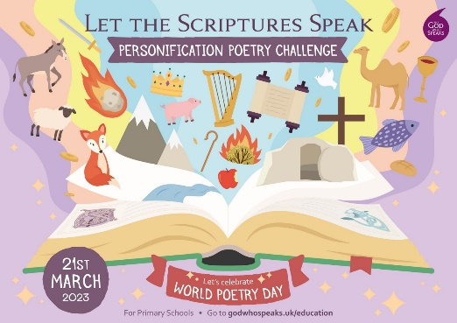
Discussion part 1.
In pairs, and then as a whole group, talk about elements of language that make powerful personification (for example: descriptive language and creative license used for movement, thoughts and feelings, the addition of alliteration, rhyme and repetition, etc.)
Write these on large sheets of paper for your working wall.
Use partner work for pupils to scaffold ideas to form personification phrases of their own.

Discussion part 2.
Using the Scriptures as inspiration for personification can open up many diverse themes and topics.
What does the Bible say about being a good neighbour?
What does the Bible say about hope, compassion, forgiveness and other virtues?
What can objects, animals, places and other things in the Bible reveal to us?
These are just some examples of themes that you can use.
Bible stories are often multi-layered, and you will find overlapping themes, but you can choose to focus on a key message from a different or unusual perspective.

Imagination
- Ask the class to think about their favorite Bible story, and or, Bible stories they know
- Ask them to discuss in pairs what it is and why they like it.
- Have some feedback and then ask them to think about the story from an object or animal’s point of view, (if there is an animal in the story!).
- How can they use their imagination to share that story?

Drafting
Although most pupils may benefit from scaffolding ideas with a partner, some pupils may have clear inspiration for their own personification poem.

- Find a hook: As a starting point encourage the pupils to think of what it is in the story that they find most interesting.
- Focus: Ask pupils what point they want to make and to keep that focus as they write.
- Shared writing: Depending on your class it may be appropriate to draft a verse together, or with a table group - adding, subtracting and swapping words to improve as you go along together.
- Encourage pupils to re-read their own work regularly, in their heads and aloud to a partner. Add or change words for improved meter.
- Get another pupil to listen to and read written the poems. Decide on corrections and improvements. Note these changes.

Polishing
Pupils are now ready to create finished poems in formats that they will be proud to share.
- Give out fresh pieces of good quality paper (line guides may come in handy for handwritten versions).
- Fire up laptops or tablets: let pupils type their poetry into text documents or create PowerPoints with added images and artwork.
- Practice performance poetry, add body percussion, dance moves, actions or images.
- Film spoken word poetry, artwork and performance poetry.

Sharing
Poetry is by definition best when read out loud! Here are some ways that pupils’ work can be shared to help encourage them, and to get their messages across in eye-catching ways.

- Create attractive wall displays in the classroom and elsewhere in school.
- Arrange for school assembly poetry recitals.
- Organise a National Poetry Day event at school where poems can be displayed and read out loud. Invite parents and other members of the community.
- Organise a reading to younger pupils in their classes.
- Build cross curricular links between the poetry and other learning i.e., R.E., History, Geography, PSHE, Art and Design.
- Organise visits to local residential homes, community centres and churches where the poems can be read out loud.
- Organise a poetry reading session at the local library or shopping centre.
- Contact a local choir to organise an event with songs and your poetry interspersed.
- Contact the local paper to offer an article with your pupils’ poetry in, ask for someone to come along to interview your pupils about their poetry.
- Contact the local radio station and arrange an interview to talk about the National Poetry Day and your pupils’ poetry.
- Put the poetry into a booklet to sell in your local community and amongst parents.
- Celebrate with a neighbouring school by running a joint poetry session.

Conclusion
Each school taking part can submit up to five poems to our Poetry Challenge team at Bible Society, who will select the most original and imaginative poems for posting live in the autumn on our God who Speaks and Bible Society websites and/or social media channels.
How to submit your poems
Please select the five best poems from those done by your pupils and send them to:
poetrychallenge@biblesociety.org.uk
Please provide the first name of the child who wrote each poem along with the name of your school – we will use this information in the attribution for the poems that we select to publish on our website and/or social media channels.

Let the Scriptures Speak is a poetry challenge for primary schools run by Bible Society with The God Who Speaks and written by Tony Bower.

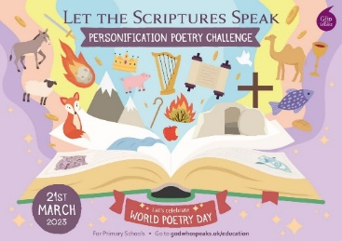
Deadline
The deadline for poems is 31st May 2023.

What next?
A panel of three people will read all the poems that we receive.
The panel consists of:
Fleur Dorrell – Catholic Scripture Engagement Manager for the Catholic Bishops’ Conference and Bible Society. National Co-ordinator of the God who Speaks initiative.
Mike Otter – Head of Education, Bible Society
Tony Bower – Poet, York Schools and Youth Trust

The panel will select poems for posting live in the autumn on our God who Speaks and Bible Society websites. The poems that we use will be credited using the name of the school and the child’s first name.

We will be looking for imagination, originality, integrity of understanding the Bible story or text that has inspired the poem, and good grammar (teachers - please help where appropriate).
The ingredients that will make a very tasty poem are:

Imagination:
What would the water say in the miracle at Cana?
‘I used to be H20
But now what do you know?’

Originality:
What would the sling or the stone say in the story of David and Goliath?
(Please do not send in five poems about the same story and from the same perspective)

Integrity:
In retelling the Bible story please don’t tell a different story! A fresh angle not a false account. Please show good clear Bible knowledge.

Grammar:
Please ensure that poems are written in grammatically correct language so that their power is understood more quickly.
Our objectives:
We will inform all selected poets as to when their poems will be live on our websites.
We hope you will enjoy the challenge.
We hope to publish a book of the best poems next year.
We include four sample poems at the end to help you get creative in the classroom.

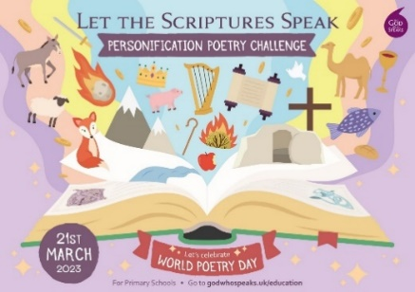

Our Four Sample Poems
A whale of a tale  Deep, deep down in my dark cavern  I hear a man’s heart praying to heaven  He sits in darkness  Searching for the light  Wishing for a chance  To do what’s right  Deep, deep down in my dark cavern  I hear a man’s heart praying to heaven  He sits in my squishy squashy belly  He sits in my  Blubbery  Big fat  Belly  Feeling his faith  Wobblier than jelly  Deep, deep down in my dark cavern  I hear a man’s heart praying to heaven  The Ocean maker  The world creator  Cares for this creature  And gives him a future  Forgiveness and grace  Wider than the ocean  Forgiveness and grace  Deeper than the ocean  BURP!  Bye Bye Jonah | Storm Speaking  I know I got the boat  By its wooden throat  But I was only playing  Making it go swaying  In the Sea of Galilee  YIPEE!  The lightning joins the fun  Lights the sky like the sun  The thunder brings the tune  Big base going BOOM! BOOM! BOOM!  I know I got the…  There we are creating a storm  Hearing voices shouting:  ‘This isn’t the norm’  ‘Save us  Save us  Jesus save us  From harm’  Repeat  And then we stop to listen  The lightning  The thunder  The stormy sea  (That’s me)  We all stopped to hear  The voice that silences fear  The voice that stills the storm  The voice that fills you with calm  We all stopped playing with the tiny boat  And watch it glide and gently float  Ssh! Ssh! Ssh!  As Jesus stills my waves

Rip roaring story

Telling Tips:
After you say the word gong, everyone shouts GONG!, when you say the word roar, everyone shouts ROAR, and when you say the word snore, everyone snores.
It is great fun!

When it’s dinner time it’s like a gong  GONG!  Going off in our belly  When it’s time to eat it’s like a gong  GONG!  Going off in our tummy  And we want to roar  ROAR  For evermore  We want to roar  ROAR  For food that we adore  One dark and hungry night  We saw a snack in sight  And it was like a gong  GONG  Going off in our head  And it was like a gong  GONG  Going off as our pride said  Roar  ROAR  We were going to attack the snack  With a mighty roar  ROAR  But then suddenly  With the speed of light  There was a dizzying  Dazzling  Heavenly light | A calming  Soothing  Glowing light  Our mighty roar  ROAR  Turned into the deepest  Loudest  Snore  Zzzzzzz  Zzzzzz  The deepest  Longest  Snore  Zzzzzzzzzz  Zzzzzzzzzz  And our snack smiles  As we play sleeping lions  On the floor  With the gentlest  Quietest  Snore  Zzzzzz  Zzzzzz

Carrying all hope

I have Moses in my basket
Don’t want it to be a casket

Need to protect an infant child
In a world gone violently wild

I have Moses in my basket
Don’t want it to be a casket

Sailing down the nighttime Nile
Hearing voices viciously vile

I have Moses in my basket
Don’t want it to be a casket

Listen to the song of the river
Not screams to make you shiver

I have Moses in my basket
Don’t want it to be a casket

Why the fear of a different race
Where’s the loving gift of grace

I have Moses in my basket
Don’t want it to be a casket

I have Moses in my basket
Don’t want it to be a casket

