Queens in the Bible
There are four types of queens found in the Bible: queen consorts who were married to the king; queen mothers who were mothers of the king; queen regents who ruled on behalf of their young sons; and queens regnant, who ruled in their own right. In English we have one word for ‘queen’ to cover the roles of what are different words in Hebrew.

Queen Consorts
Queen consorts are women married to the king, or in the case of Egypt, the Pharaoh. Bathsheba was married to King David in 2 Samuel 11 and 12; 1 Kings 1 and 2; and was the mother of King Solomon. Actually, not all wives of kings were queens. Some kings had many wives in a harem, and these women were not all considered as queens, such as King Solomon’s harem in 1 Kings 11:3. There are some well-known queen consorts in the Bible such as Queen Jezebel, the wife of King Ahab of Israel, who was notorious for introducing pagan worship in 1 Kings 16 – 2 Kings 9. The most famous queen consort in the Bible is Queen Esther, who was married to the Emperor of Persia, who replaced Queen Vashti in his affections. The biblical book of Esther tells her story.
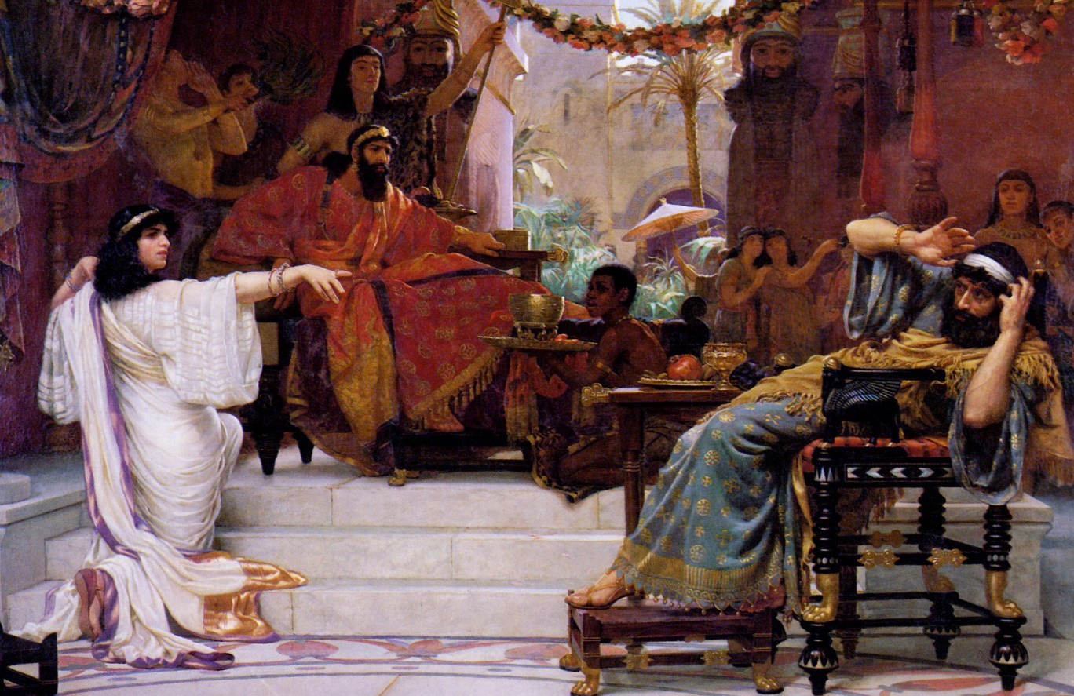
Esther Denouncing Haman by Ernest Normand. 1888.

Queen Mothers in in the Bible
Queen mothers are often specifically named in the Old Testament. When the text introduces a new king of Judah in 1 Kings, 2 Kings and 2 Chronicles, it nearly always mentions the name of the king’s mother. Often, she was the most powerful woman in the court. The queen mother would sometimes intercede on behalf of others. In 1 Kings 2: 13-21 we read of Adonijah who went to the queen mother, Queen Bathsheba, to intercede with King Solomon for his request. The role could be removed. In 1 Kings 15:9-13 we read that king Jeroboam of Israel removed Maacah from being queen mother because she made an idol to Asherah. King Lemuel’s mother was probably a queen, but her name is not recorded although she gives her son excellent advice and wisdom in his leadership role in Proverbs 31: 1-9.

Queen Regents
When kings were very young, the queen mother was often the actual ruler, ruling as regent

in the name of her son, until he was old enough to rule. For example, in 2 Kings 22:1 we read that King Josiah was 8 years old when he became king and his mother was Jedidah; and in 2 Chronicles 24:1 we read that King Joash of Judah was 7 years old when he became king, and his mother was Zibiah. The queen regent was not always the mother, but sometimes the grandmother. In 1 Kings 15:9-15 we read of the queen regent, Queen Maacah who was actually King Asa of Judah’s grandmother.

Queens Regnant
As well as queen consorts and queen mothers, the Bible records a number of queens regnant who ruled in their own right. These are the Queen of Sheba and Queen Athaliah of Judah.

Queen of Sheba
The Queen of Sheba is the first queen mentioned in the Bible. The story of her visiting King Solomon of Israel can be read in 1 Kings 10:1-13 and 2 Chronicles 9:1-12. She is unnamed but the narrative indicates that she was ruler in her own right. In the New Testament in Matthew 12:42 and Luke 11:31, she is called the Queen of the South, which most scholars believe was southern Arabia, around modern-day Yemen and maybe across the Red Sea into modern-day Ethiopia.
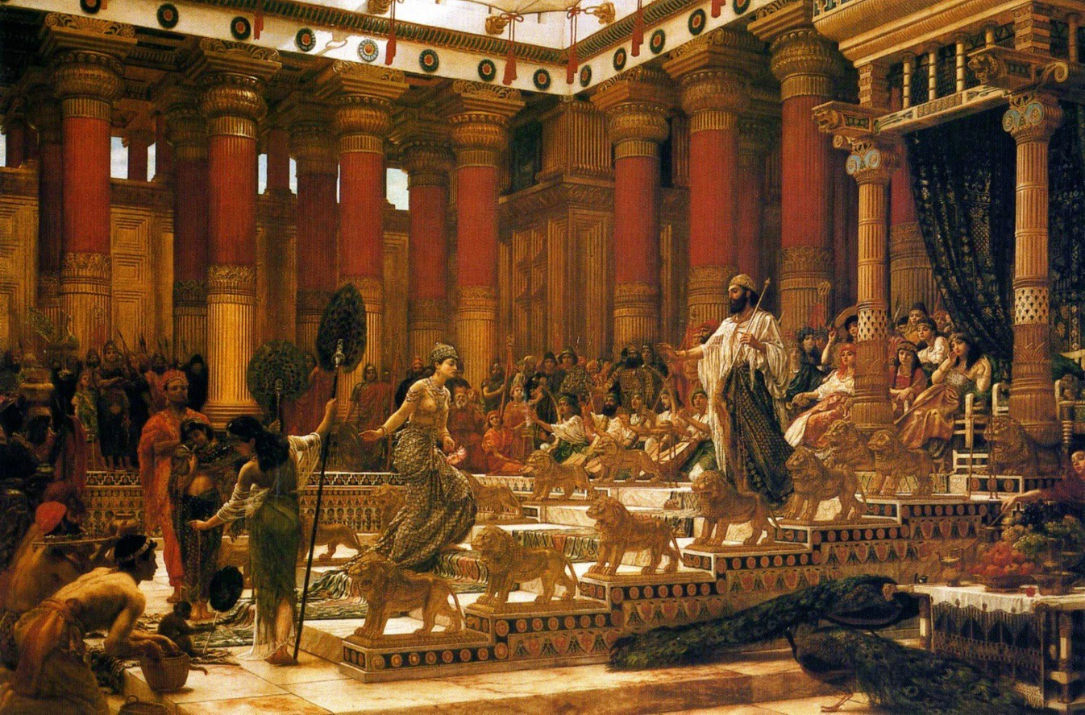
The Visit of the Queen of Sheba to King Solomon by Edward Poynter. 1890.

Queen Athaliah
The Old Testament describes just one queen regnant of Judah. Queen Athaliah ruled Judah in her own right for 6 years. Her story is recorded in 2 Kings 8:16-11:16 and 2 Chronicles 22:10 to 23:1. It used to be much better known, and she was made famous by an oratorio called Athalia, which was written by Handel in 1733.

Queen Alexandra
The last queen regnant of Judea is not mentioned in the Bible but is worth mentioning. Queen Alexandra was from the Hasmonean dynasty. She is described by Josephus and is mentioned in the Talmud and in the Dead Sea Scrolls. She supported the Pharisees over the

Sadducees. She was a ruler of Judea and died four years before the Roman conquest, and a few decades before the birth of Jesus.

Queen Candace
In Acts 8:27-39, we read the story of Philip the Evangelist who met the treasurer to the court of Queen Candace. Candace in fact was a title, like Pharaoh or Caesar, rather than the name of a specific person, and referred to a queen. The Candaces were a line of queens who ruled in Cush, which is in modern-day Sudan, in an area then known as Ethiopia in Greek. It is not clear which category of queen she was.

The Books of Kings
The Bible does not have any specific law that only men can reign or be rulers. Before the monarchy, Israel was ruled by the Judges and one of the most famous of these was Deborah. In the Septuagint translation of the Bible, from which our name of the books of Kings comes, the name of the books can better be translated as “Reigns”. By calling them the book of Kings, we can be misled into forgetting that these books also tell the stories of queens.

Good and Bad Queens
Some queens were good, and some are portrayed as bad. Others are just mentioned by name, and some are not named at all. The Queen of Sheba who comes across as a good queen is never named. The only ruling queen of Judah was Queen Athaliah who is not a good queen. Some people have argued that because she was not a good queen, that is a reason why women should not be rulers but considering that there are more examples of bad kings, by that logic men should not be rulers either.

Authority
The monarch was usually a man but sometimes a woman, and the monarch had ultimate authority. However, it seems that the queen mother came second in authority, and if she was in fact the regent, she held the actual authority until her son was old enough.

The Queen of Heaven
In the book of the prophet Jeremiah, we find intriguing references to the ‘Queen of Heaven’. She is mentioned in Jeremiah 7:18 and then in 44:17-25. This is a period after Jerusalem has fallen and many Israelites had fled to Egypt. This was the title given to a pagan goddess. Women were burning incense to her, and Jeremiah condemned worship to her. The title was ascribed to Asherah, Astarte, Isis and Ishtar, which maybe different local names for the same goddess of fertility.

Queens in Revelation
Two mysterious queens are found in Revelation. In Revelation 12:1 we read of a great wonder in heaven, with a crown of 12 stars. She is not called a queen as such, but a woman wearing a crown would be considered a queen. Revelation has had many different interpretations over the centuries, but she is usually interpreted in a number of ways: as the Church which is personified in female form as the Bride of Christ, with the 12 stars symbolising the 12 Apostles, or seen as Eve, or as Israel with the 12 stars representing the tribes, or as the Virgin Mary. Since at least 1904, the Catholic Church has seen the woman in Revelation as Mary, the mother of Jesus.

The only actual use of the word ‘queen’ in Revelation is Babylon, the great evil city, associated with corruption and immorality, which is personified as ruling as queen in Revelation 18:7.

Neil Rees is Translation and Digital Publishing Consultant for Bible Society and a freelance writer.

Mary, Queen of Heaven
Although not in the Bible, Mary has long been called Queen of Heaven in Church history. In reality the only use of the term Queen of Heaven in the Bible is actually pagan.
Nevertheless, Mary’s royal credentials were established way back in the 4th century by Gregory Nazianzen’s idea of ‘the Mother of the King of the universe’, and the ‘Virgin Mother who brought forth the King of the whole world’. Mary was proclaimed ‘Queen of Heaven’ primarily based on her role as Theotokos (translated as Mother of God), at the Council of Ephesus in AD 431. As Christ is identified as King so his mother is given the title of Queen, in the sense of a queen mother.
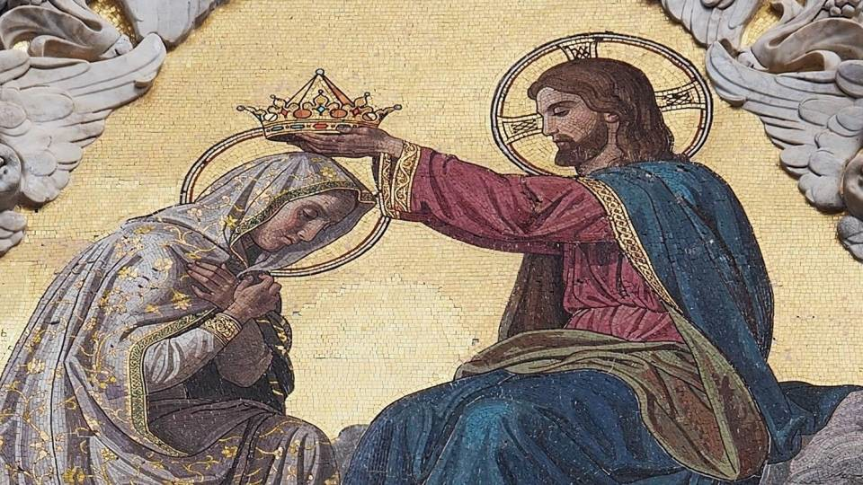
The Coronation of the Virgin. Mosaic detail on the façade of Siena Cathedral. 19th century.

Many popes promoted Mary’s royal nature such as Pope Sixtus IV in his Apostolic Letter Cum Praeexcelsa of 1476, established a Mass and Office for the Feast of the
Immaculate Conception (8th December), and referred to Mary as a ‘Queen’,... ‘Who is always vigilant to intercede with the king whom she bore’. Pope Leo XIII referred to Mary as ‘Queen of Heaven’ in his Encyclical Octobri Mens in 1891 while Pope Pius XII called her ‘Queen of the World’ in his Encyclical Ad Caeli Reginam (To the Queen of Heavens) in 1954. This Encyclical further confirmed Mary’s Queenship Feast-day on 22nd August.

Fleur Dorrell is Catholic Scripture Engagement Manager for the Catholic Bishops’ Conference and Bible Society. She is the national Co-ordinator of the God who Speaks initiative.

