The Bible’s Women’s Rights Campaigners
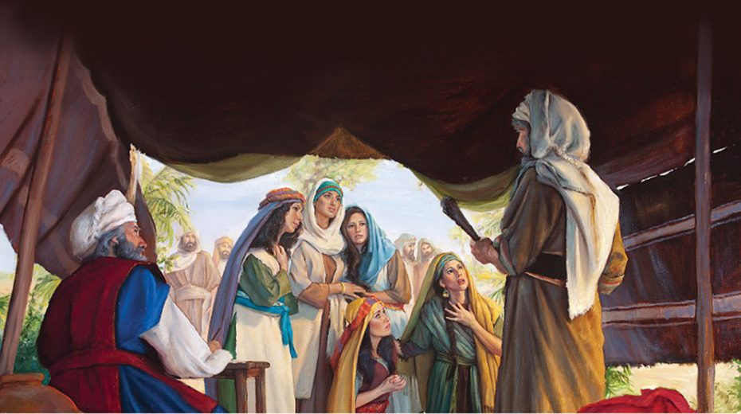
The Bible includes the world’s first recorded women’s right campaigners. The five daughters of Zelophehad changed an unfair Old Testament law. Here is the story...
Background
The story is set when the Israelites were in exile for 40 years during the exodus. The promised land had been spied out, and the Israelites are gathered on the plains of Moab by the Jordan across from Jericho. The land was apportioned according to the names of the men in the census, as recorded in Numbers. Only men over the age of 20 were counted in the census (Numbers 1:45-46), because it was mainly taken as a muster for military service.
Zelophehad
One of these men was Zelophehad, who had left Egypt with Moses. He was the son of Hepher, son of Gilead, son of Machir, son of Manasseh, who was one of the 2 sons of Joseph. (Numbers 27:1). Zelophehad had no sons but he had 5 daughters. The Bible doesn’t usually record the names of women unless they are significant to the narrative, but all five of them are named here. They were called Mahlah, Noa, Hoglah, Milcah and Tirzah, and they had been born during the exodus, (Numbers 26:33) before Zelophehad died in the wilderness.
Zelophehad’s daughters
In the early days, women could not inherit. When Zelophehad died (Numbers 36:13) leaving his five daughters, they felt this was unfair and they wanted to inherit their father’s property. The Bible records their determination because ‘they stood before Moses and before Eleazar the priest and before the chiefs and all the congregation, at the entrance of the tent of meeting’ (Numbers 27:2). They spoke boldly and explained the injustice of the situation before Moses, and Eleazer the priest, who was now High Priest after the death of his father Aaron (Numbers 20:28).
The daughters explained that Zelophehad had been loyal to Moses and had not taken part in Korah’s rebellion (Numbers 27:3). They said ‘Why should the name of our father be done away from among his family, because he had no son?’ (Numbers 27:4, KJV) and Moses ‘brought their case before the Lord’. (Numbers 27:5, KJV)
As a result, it was agreed that not only could they inherit, but in addition the anomaly in the law was actually changed so that ‘If a man die, and have no son, then ye shall cause his inheritance to pass unto his daughter.’ (Numbers 27:8, KJV). We read that later they did receive their inheritance in the promised land (Joshua 17:3-6).
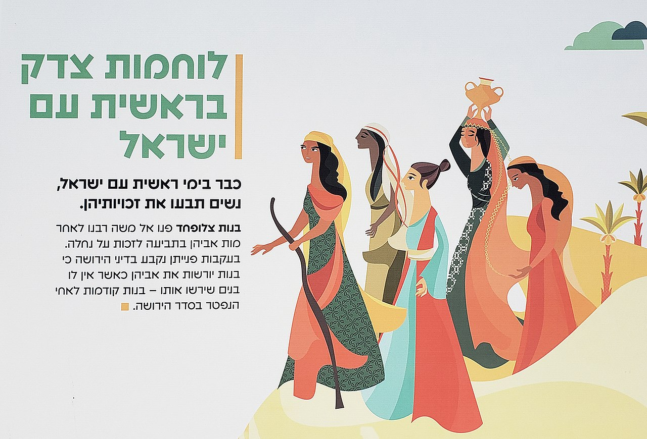
Other female inheritance in the Bible
The daughters of Zelophehad were perhaps the world’s first recorded women’s rights campaigners. However, it was not the only case of female inheritance in the Old Testament. Job gave inheritance to his sons and his daughters (Job 42:15), and we also read of Achsah, daughter of Caleb (1 Chronicles 2:49) who requests and receives an inheritance of land and water resources. (Judges 1:9-15). In the New Testament in Romans, we read that we are all ‘heirs of God, and joint-heirs with Christ; if so be that we suffer with him, that we may be also glorified together’.
New Testament
In the New Testament, Jesus treats women fairly. Although none of his 12 apostles were women, there were many women amongst his disciples. Those specifically named are Mary and Martha, sisters of Lazarus, Mary Magdalene, Joanna wife of Herod’s steward Chuza, Susanna (Luke 8:2-3) and Salome. In Mark 15:41 it says many woman came to him in Jerusalem. His fairness in defending women is seen in the story of the women caught in adultery (John 7:53 – 8:11).
Afterlife of the story
The story of Zelophehad’s daughters had significance in British history during some debates on succession to the throne. In the 1140s it was quoted to back up the claim for Matilda, only surviving child of King Henry I, to inherit the throne. Matilda was never formally declared Queen of England and was instead titled ‘Lady of the English’, but her son succeeded to the throne as Henry II in 1154. So in England, the story established the principle that women can inherit the throne, and inheritance can go down the female line. This paved the way for the Tudor princesses Mary and Elizabeth to be heirs after the death of their brother Edward VI. This allowed for the accession of Queen Mary I in 1553, and later Queen Elizabeth I in 1558. In Scotland the story of Zelophehad’s daughters was quoted in debates about whether it allowed King James V’s only child Princess Mary to become queen, which she later did as Mary Queen of Scots in 1564.
Fiddler on the Roof
You may also know an echo of this story because it has influenced modern literature. The idea of a man with five daughters is also used as a theme in the story Fiddler on the Roof. The fiddler is a pious Jewish dairyman called Tevye living in the Ukraine. He has five daughters called Tzeitel, Hodel, Chava, Shprintze and Bielkewho, who each need a dowry. Fiddler on the Roof was originally called ‘Tevye and his Daughters’ – a series of stories by Sholem Aleichem written in Yiddish between 1894-1914. It tells the story of Jewish life in a little fictional village of Anatevka, at the turn of the 19th century, in a region of Imperial Russia which is now in the Ukraine. It was made into the musical in 1964.
Jane Austen
Jane Austen also picks up the idea in her book Pride and Prejudice, published in 1813. Mr. Bennet inherited his estate under a legal entail, that stated he could only leave the estate to a male member relative. That was not a concern at first, because he presumed to have a son who would one day inherit. But instead, like Zelophehad, the plot revolves around the fact that he had five daughters, called Jane, Mary, Catherine, Lydia, and Elizabeth, who could not inherit.
If you are not familiar with the original story of Zelophehad’s daughters, you can read it in Numbers 27:1-11.
Neil Rees is Translation and Digital Publishing Consultant for Bible Society and a freelance writer.

